Błażej Piekoś 273210

Wyniki:

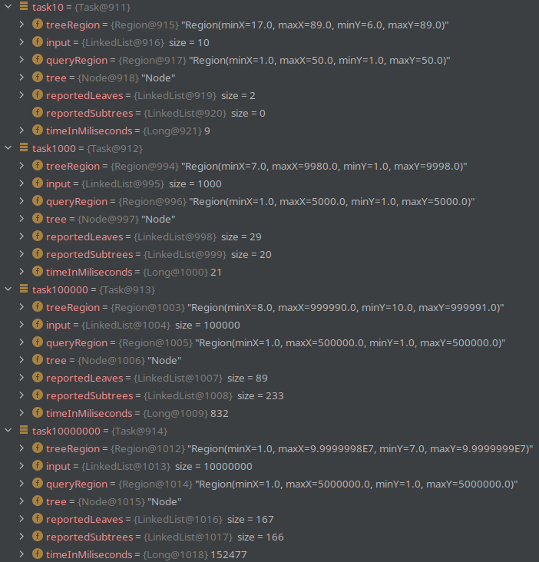

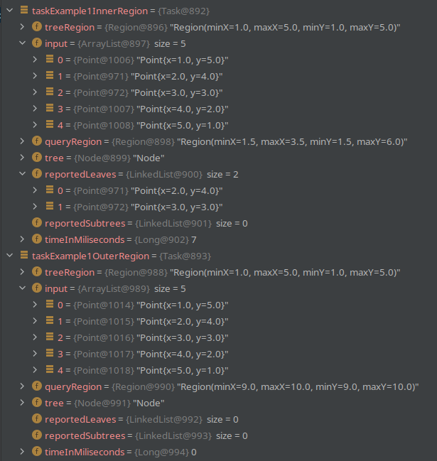

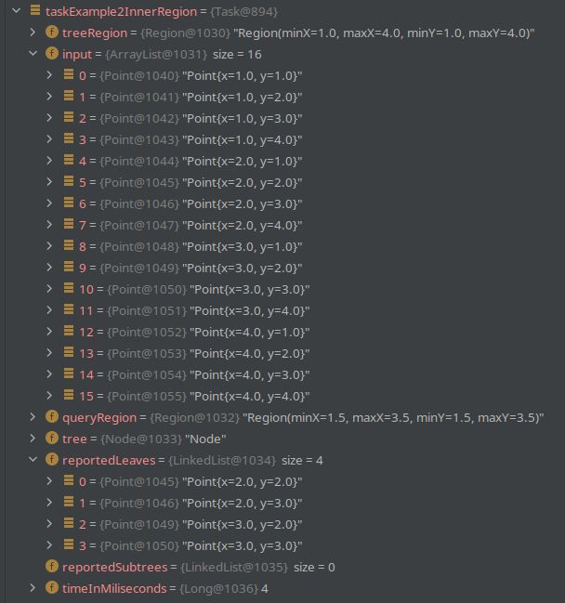

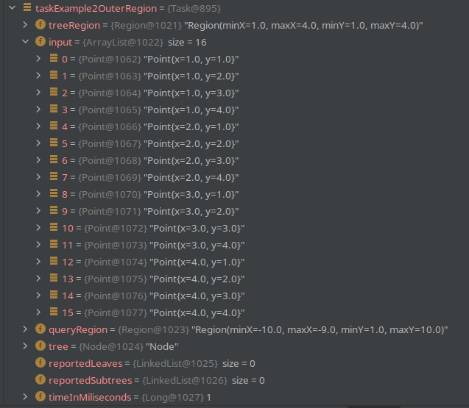

Kod:

package model;
import com.google.common.collect.Lists;
import java.util.List;
import lombok.AllArgsConstructor;
import lombok.Data;
import lombok.NoArgsConstructor;
@AllArgsConstructor
@NoArgsConstructor
@Data
public class Input {
private List<Point> points = Lists.newLinkedList();
private Region region = new Region();
}
package model;
import lombok.AllArgsConstructor;
import lombok.Data;
import lombok.NoArgsConstructor;
@AllArgsConstructor
@NoArgsConstructor
@Data
public class Node {
private Double location;
private NODE_TYPE type;
private Point point;
private Node parent;
private Node left;
private Node right;
private Region region;
public Node(
Double location,
NODE_TYPE type,
Point point,
Node left,
Node right
) {
this.location = location;
this.type = type;
this.point = point;
this.left = left;
this.right = right;
}
public boolean isLeaf() {
return this.left == null && this.right == null;
}
public void setRegion(Region region) {
this.region = new Region();
this.region.of(region);
}
public boolean isLeft() {
return this == this.parent.left;
}
public boolean isRight() {
return this == this.parent.right;
}
@Override
public String toString() {
return "Node";
}
public enum NODE_TYPE {
LEAF,
VERTICAL_LINE,
HORIZONTAL_LINE;
}
}
package model;
import model.Node.NODE_TYPE;
public class NodeBuilder {
/**
* Stworzenie node'a na podstawie argumentów.
*
* @param location
* @param type
* @param point
* @param left
* @param right
*/
public Node build(
Double location,
NODE_TYPE type,
Point point,
Node left,
Node right
) {
Node node = new Node(
location,
type,
point,
left,
right
);
if (left != null) {
left.setParent(node);
node.setLeft(left);
}
if (right != null) {
right.setParent(node);
node.setRight(right);
}
return node;
}
}
package model;
import java.util.Objects;
import java.util.UUID;
import lombok.AllArgsConstructor;
import lombok.Data;
import lombok.NoArgsConstructor;
@AllArgsConstructor
@NoArgsConstructor
@Data
public class Point {
private UUID id = UUID.randomUUID();
private double x;
private double y;
public Point(
Double x,
Double y
) {
this.x = x;
this.y = y;
}
@Override
public boolean equals(Object o) {
if (this == o) {
return true;
}
if (o == null || getClass() != o.getClass()) {
return false;
}
Point point = (Point) o;
return Double.compare(point.x, x) == 0 && Double.compare(point.y, y) == 0;
}
@Override
public int hashCode() {
return Objects.hash(x, y);
}
}
package model;
import lombok.Data;
import lombok.NoArgsConstructor;
@NoArgsConstructor
@Data
public class Region {
private Double minX;
private Double maxX;
private Double minY;
private Double maxY;
/**
* Stworzenie rejonu z prawodilowy przypisaniem wartosci minimalnych/maksymlanych
*
* @param minX
* @param maxX
* @param minY
* @param maxY
*/
public Region(
Double minX,
Double maxX,
Double minY,
Double maxY
) {
double temporary;
if (minX > maxX) {
temporary = minX;
minX = maxX;
maxX = temporary;
}
if (minY > maxY) {
temporary = minY;
minY = maxY;
maxY = temporary;
}
this.minX = minX;
this.maxX = maxX;
this.minY = minY;
this.maxY = maxY;
}
/**
* Skopiowanie wartosci z danego rejonu do instacji
*
* @param region
*/
public void of(Region region) {
this.minX = region.getMinX();
this.maxX = region.getMaxX();
this.minY = region.getMinY();
this.maxY = region.getMaxY();
}
}
package model;
import com.google.common.collect.Lists;
import java.util.Collections;
import java.util.List;
import model.Node.NODE_TYPE;
import service.RegionComparator;
public class Task {
public Region treeRegion = new Region(
0.0,
0.0,
0.0,
0.0
);
private List<Point> input = Lists.newArrayList();
private Region queryRegion;
private Node tree;
private List<Point> reportedLeaves = Lists.newLinkedList();
private List<Node> reportedSubtrees = Lists.newLinkedList();
private Long timeInMiliseconds = 0L;
public Task(
Input input,
Region queryRegion
) {
this.input = input.getPoints();
this.treeRegion = input.getRegion();
this.queryRegion = queryRegion;
this.run();
}
/**
* Metoda fasadowa. Uruchamia poszczegolne etapy algorytmu.
*/
public void run() {
try {
long start = System.currentTimeMillis();
this.tree = this.buildKdTree(
this.input,
0
);
this.tree.setRegion(this.treeRegion);
this.defineRegion(this.tree);
this.checkAffiliationToQueryRegion(this.tree);
this.timeInMiliseconds = System.currentTimeMillis() - start;
} catch (Exception exception) {
System.out.println(exception.getMessage());
}
}
/**
* Walidacja obszaru zapytania
*
* @throws Exception
*/
public void validateQueryRegion() throws Exception {
if (this.queryRegion != null) {
if (this.queryRegion.getMinX() > this.queryRegion.getMaxX()
|| this.queryRegion.getMinY() > this.queryRegion.getMaxY()) {
throw new Exception("Nieprawidłowy obszar zapytania");
}
}
}
/**
* Walidacja danych wejsciowych
*
* @throws Exception
*/
public void validateAmountOfPoints() throws Exception {
if (this.input.size() == 0) {
throw new Exception("Nie podano punktów.");
}
}
/**
* Walidacja danych wejsciowych
*
* @throws Exception
*/
public void validateDifferenceOfX(
Point left,
Point right
) throws Exception {
if (left.getX() == right.getX()) {
throw new Exception("Współrzędne x są takie same w punktach");
}
}
/**
* Walidacja danych wejsciowych
*
* @throws Exception
*/
public void validateDifferenceOfY(
Point left,
Point right
) throws Exception {
if (left.getY() == right.getY()) {
throw new Exception("Współrzędne y są takie same w punktach");
}
}
/**
* Budowanie kd drzewa na podstawie punktow z argumentu metody. Złozoność O(n).
*
* @param points
* @param d
*/
public Node buildKdTree(
List<Point> points,
Integer d
) {
if (points.size() == 1) {
return new NodeBuilder().build(
0d,
NODE_TYPE.LEAF,
points.get(0),
null,
null
);
} else if (points.size() == 0) {
return null;
}
Integer axis = d % 2;
NODE_TYPE type = axis == 0 ? NODE_TYPE.VERTICAL_LINE : NODE_TYPE.HORIZONTAL_LINE;
double median = this.calculateMedian(
axis,
points
);
List<Point> leftPoints = Lists.newLinkedList();
List<Point> rightPoints = Lists.newLinkedList();
for (Point temporary : points) {
double value = axis == 0 ? temporary.getX() : temporary.getY();
if (value <= median) {
leftPoints.add(temporary);
} else {
rightPoints.add(temporary);
}
}
Node leftSubtree = this.buildKdTree(
leftPoints,
d + 1
);
Node rightSubtree = this.buildKdTree(
rightPoints,
d + 1
);
Node newNode = new NodeBuilder().build(
median,
type,
null,
leftSubtree,
rightSubtree
);
return newNode;
}
/**
* Liczenie mediany z punktow wzgledem osi x lub y z argumentu
*
* @param axis
* @param points
*/
public Double calculateMedian(
Integer axis,
List<Point> points
) {
Double median = axis == 0 ? this.calculateMedianByX(points) : this.calculateMedianByY(points);
return median;
}
/**
* Liczenie mediany punktow wzgledem osi x
*
* @param points
*/
public Double calculateMedianByX(
List<Point> points
) {
this.sortByX(points);
Integer half = points.size() / 2;
Double median = (points.size() % 2 == 0) ?
((points.get(half).getX() + points.get(half - 1).getX()) / 2)
: points.get(half).getX();
return median;
}
/**
* Liczenie mediany punktow wzgledem osi y
*
* @param points
*/
public Double calculateMedianByY(
List<Point> points
) {
this.sortByY(points);
Integer half = points.size() / 2;
Double median = (points.size() % 2 == 0) ?
((points.get(half).getY() + points.get(half - 1).getY()) / 2)
: points.get(half).getY();
return median;
}
/**
* Sortowanie po osi x
*
* @param points
*/
public void sortByX(List<Point> points) {
points.sort((p1, p2) -> {
if ((p1.getX() < p2.getX()) || (p1.getX() == p2.getX() && p1.getY() < p2.getY())) {
return -1;
} else if (p1.getX() > p2.getX()) {
return 1;
} else {
return 0;
}
});
}
/**
* Sortowanie po osi y
*
* @param points
*/
public void sortByY(List<Point> points) {
Collections.sort(points, (p1, p2) -> {
if ((p1.getY() < p2.getY()) || (p1.getY() == p2.getY() && p1.getX() < p2.getX())) {
return -1;
} else if (p1.getY() > p2.getY()) {
return 1;
} else {
return 0;
}
});
}
/**
* Zdefiniowanie rejonu punktow node'a z argumentu metody. Rekurencyjnie sprawdza rejony dla
* dzieci.
*
* @param node
*/
public void defineRegion(Node node) {
if (!node.isLeaf()) {
if (node.getParent() != null) {
node.setRegion(
node.getParent().getRegion()
);
Region nodeRegion = node.getRegion();
Double location = node.getParent().getLocation();
if (nodeRegion != null && location != null) {
if (NODE_TYPE.HORIZONTAL_LINE.equals(node.getType())) {
if (node.isLeft()) {
nodeRegion.setMaxX(location);
} else {
nodeRegion.setMinX(location);
}
} else {
if (node.isLeft()) {
nodeRegion.setMaxY(location);
} else {
nodeRegion.setMinY(location);
}
}
node.setRegion(nodeRegion);
}
}
if (node.getLeft() != null) {
this.defineRegion(
node.getLeft()
);
}
if (node.getRight() != null) {
this.defineRegion(
node.getRight()
);
}
}
}
/**
* Sprawdza czy node znajduje sie w obszarze zapytania i dodaje go do zgloszonych elementow
*
* @param node
*/
public void checkAffiliationToQueryRegion(Node node) {
if (node.isLeaf()) {
this.checkLeafAffiliationToQueryRegion(node);
} else {
if (node.getLeft().isLeaf()) {
this.checkLeafAffiliationToQueryRegion(node.getLeft());
} else {
this.checkSubtreeAffiliationToQueryRegion(node.getLeft());
}
if (node.getRight().isLeaf()) {
this.checkLeafAffiliationToQueryRegion(node.getRight());
} else {
this.checkSubtreeAffiliationToQueryRegion(node.getRight());
}
}
}
/**
* Sprawdza czy lisc przynalezy do obszaru zapytania
*
* @param node
*/
public void checkLeafAffiliationToQueryRegion(Node node) {
Boolean contained = this.containedInRegion(
this.queryRegion,
node.getPoint()
);
if (contained) {
this.reportedLeaves.add(
node.getPoint()
);
}
}
/**
* Sprawdza czy poddrzewo znajduje sie w obszarze zapytania
*
* @param node
*/
public void checkSubtreeAffiliationToQueryRegion(Node node) {
if (
node != null
&& this.queryRegion != null
&& new RegionComparator(
node.getRegion(),
this.queryRegion).isNodeRegionContainedInQueryRegion()
) {
this.reportedSubtrees.add(node);
} else if (
node != null
&& this.queryRegion != null
&& new RegionComparator(
node.getRegion(),
this.queryRegion).isNodeRegionIntersectionOfQueryRegion()
) {
this.checkAffiliationToQueryRegion(node);
} else {
if (node.isLeaf()) {
this.checkLeafAffiliationToQueryRegion(node);
}
}
}
/**
* Sprawdza czy punkt z argumentu znajduje sie danym rejonie z argumentu
*
* @param region
* @param point
*/
public Boolean containedInRegion(
Region region,
Point point
) {
Boolean pointInRegion = point.getX() >= region.getMinX() && point.getX() <= region.getMaxX()
&& point.getY() >= region.getMinY() && point.getY() <= region.getMaxY();
return pointInRegion;
}
}
package service;
import com.google.common.collect.Lists;
import com.google.common.collect.Sets;
import java.util.List;
import java.util.Random;
import java.util.Set;
import lombok.AllArgsConstructor;
import lombok.Data;
import lombok.NoArgsConstructor;
import model.Input;
import model.Point;
import model.Region;
@AllArgsConstructor
@NoArgsConstructor
@Data
public class InputBuilder {
private Integer amount;
/**
* Tworzy liste z losowymi wartosciami oraz rejon w obrebie ktorego znajduja sie te wartosci
*/
public Input build() {
List<Point> points = Lists.newLinkedList();
List<Double> xPoints = this.buildListOfRandomDouble();
List<Double> yPoints = this.buildListOfRandomDouble();
Double minX = xPoints.get(0);
Double maxX = xPoints.get(0);
Double minY = yPoints.get(0);
Double maxY = yPoints.get(0);
for (int i = 0; i < this.amount; i++) {
Point point = new Point(
xPoints.get(i),
yPoints.get(i)
);
points.add(point);
if (point.getX() < minX) {
minX = point.getX();
}
if (point.getX() > maxX) {
maxX = point.getX();
}
if (point.getY() < minY) {
minY = point.getY();
}
if (point.getY() > maxY) {
maxY = point.getY();
}
}
Region region = new Region(
minX,
maxX,
minY,
maxY
);
Input input = new Input(
points,
region
);
return input;
}
/**
* Tworzy liste z losowymi wartosciami
*/
public List<Double> buildListOfRandomDouble() {
Set<Double> doubles = Sets.newLinkedHashSet();
double randomDouble;
int randomInt;
Random random = new Random();
while (doubles.size() != this.amount) {
randomInt = random.nextInt(this.amount * 10);
randomInt = randomInt < 0 ? randomInt * -1 : randomInt;
randomDouble = randomInt;
doubles.add(randomDouble);
}
List<Double> result = doubles.stream().toList();
return result;
}
}
package service;
import lombok.AllArgsConstructor;
import lombok.Data;
import lombok.NoArgsConstructor;
import model.Point;
import model.Region;
@AllArgsConstructor
@NoArgsConstructor
@Data
public class RegionComparator {
private Point topRightQueryPoint;
private Point bottomLeftQueryPoint;
private Point topRightNodePoint;
private Point bottomLeftNodePoint;
public RegionComparator(
Region node,
Region query
) {
this.topRightQueryPoint = new Point(
query.getMaxX(),
query.getMaxY()
);
this.bottomLeftQueryPoint = new Point(
query.getMinX(),
query.getMinY()
);
this.topRightNodePoint = new Point(
node.getMaxX(),
node.getMaxY()
);
this.bottomLeftNodePoint = new Point(
node.getMinX(),
node.getMinY()
);
}
/**
* Sprawdza czy node znajduje sie w obszarze zapytania
*/
public Boolean isNodeRegionContainedInQueryRegion() {
boolean condition1 = this.topRightNodePoint.getX() <= this.topRightQueryPoint.getX();
boolean condition2 = this.topRightNodePoint.getY() <= this.topRightQueryPoint.getY();
boolean condition3 = this.bottomLeftNodePoint.getX() >= this.bottomLeftQueryPoint.getX();
boolean condition4 = this.bottomLeftNodePoint.getY() >= this.bottomLeftQueryPoint.getY();
boolean result = condition1 && condition2 && condition3 && condition4;
return result;
}
/**
* Sprawdza czy node przecina obszar z zapytania
*/
public Boolean isNodeRegionIntersectionOfQueryRegion() {
boolean condition1 = this.topRightQueryPoint.getX() < this.bottomLeftNodePoint.getX();
boolean condition2 = this.bottomLeftQueryPoint.getX() > this.topRightNodePoint.getX();
boolean condition3 = this.topRightQueryPoint.getY() < this.bottomLeftNodePoint.getY();
boolean condition4 = this.bottomLeftQueryPoint.getY() > this.topRightNodePoint.getY();
boolean result = condition1 || condition2 || condition3 || condition4 ? false : true;
return result;
}
}

